**27.How to take linear model summary using statsmodels library in python?**

**Objective:**

* To take the summary of linear model for the given variable using python.

**Process:**

* Import necessary libraries.
* Load the sample data set.
* Assign the independent(X) and dependent(y) variables.
* Pass the variables to the model.
* In sklearn library, don’t have method like summary().

**Source code:**

#import related libraries

import pandas as pd

#import statsmodel

import statsmodels.api as sm

#load sample data

data={'salary':[100,200,300,400,500,400,300,200,100,50],'age':[25,26,25,23,30,29,23,23,25,25],

'rating':[4,3.24,2.5,2.25,2,2.25,2.5,2.75,3.2,4.2], 'bonus':[2500,1200,900,3000,1800,1400,850,250,750,

1000]}

#create data frame

df=pd.DataFrame(data)

#assign independent variable

X = df.iloc[:, :1].values

#assign dependent variable

y = df.iloc[:, 3].values

#build regression model

model=sm.OLS(y,X).fit()

#take summary of model

result=model.summary()

#print the result

print(result)

**Screen shot:**

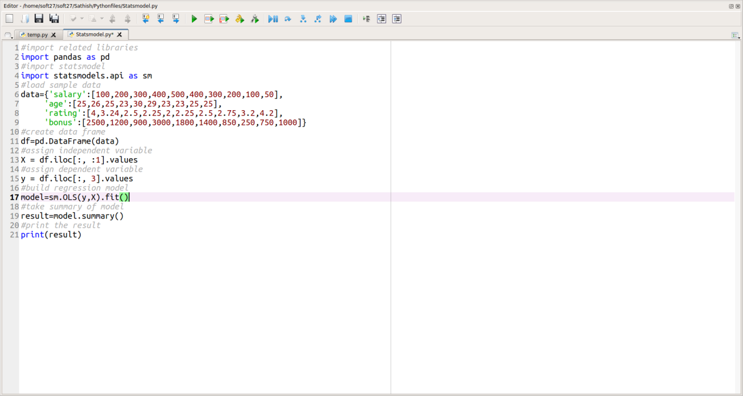

**Output:**

